**Normalization Process Details**

1. **Users Table**

Schema

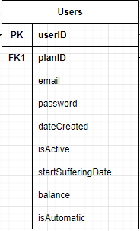

Sample Data

|  |  |  |  |  |  |  |  |  |
| --- | --- | --- | --- | --- | --- | --- | --- | --- |
| **userID** | **planID (FK)** | **email** | **password** | **dateCreated** | **isActive** | **startSuffereingDate** | **balance** | **isAutomatic** |
| **1** | **3** | **mike@..** | **123** | **12/12/12** | **0** | **12/12/19** | **-10.00** | **true** |
| **2** | **4** | **doc@..** | **324** | **12/11/20** | **1** | **NULL** | **33.00** | **false** |
| **3** | **5** | **car@..** | **6513** | **12/23/21** | **1** | **NULL** | **44.00** | **false** |

**1NF**: This table is in 1NF because all the columns hold atomic values.

**2NF**: This table is in 2NF because it is in 1NF and there are no partial dependencies.

**3NF**: This table is in 3NF because it is in 2NF and no non-prime is functionally

dependent on a field that is not part of the candidate key.

1. **Plans Table**

Schema

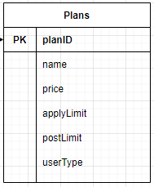

Sample Data

|  |  |  |  |  |  |
| --- | --- | --- | --- | --- | --- |
| **planID** | **name** | **price** | **applyLimit** | **postLimit** | **userType** |
| **1** | **Prime** | **12.00** | **0** | **5** | **admin** |
| **2** | **Gold** | **16.00** | **NULL** | **0** | **employee** |
| **3** | **Special** | **17.00** | **0** | **NULL** | **employer** |
| **4** | **Prime** | **17.00** | **0** | **5** | **employer** |

**1NF**: This table is in 1NF because all the columns hold atomic values.

**2NF**: This table is in 2NF because it is in 1NF and there are no partial dependencies.

**3NF**: This table is in 3NF because it is in 2NF and no non-prime is functionally

dependent on a field that is not part of the candidate key.

1. **Profiles Table**

Schema

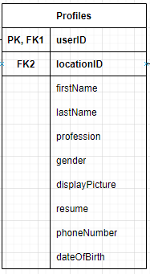

Sample Data

|  |  |  |  |  |  |  |  |  |  |
| --- | --- | --- | --- | --- | --- | --- | --- | --- | --- |
| **userID** | **locationID (FK)** | **firstName** | **lastName** | **profession** | **gender** | **displayPicture** | **resume** | **phoneNumber** | **dateOfBirth** |
| **1** | **1** | **Arunraj** | **Adlee** | **Doctor** | **m** | **pic.jpg** | **cv.pdf** | **514** | **20/24/88** |
| **2** | **2** | **Leo** | **Silao** | **Engineer** | **m** | **pic2.jpg** | **cv2.pdf** | **231** | **12/01/15** |
| **3** | **1** | **Jon** | **Doe** | **Engineer** | **f** | **pic3.jpg** | **cv3.pdf** | **123** | **12/12/96** |
| **4** | **2** | **Mike** | **Conway** | **Lawyer** | **f** | **pic4.jpg** | **cv4.pdf** | **4455** | **12/12/20** |

**1NF**: This table is in 1NF because all the columns hold atomic values.

**2NF**: This table is in 2NF because it is in 1NF and there are no partial dependencies.

**3NF:** This table is in 3NF because it is in 2NF and there are no transitive dependencies

as all columns depend only on the userID key.

1. **Locations Table**

Schema

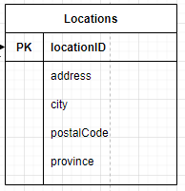

Sample Data

|  |  |  |  |  |
| --- | --- | --- | --- | --- |
| **locationID** | **address** | **city** | **postalCode** | **province** |
| **1** | **1095 Dog House** | **Montreal** | **H2M 1F8** | **quebec** |
| **2** | **23123 Park Street** | **Altoona** | **35952** | **Alabama** |

**1NF**: This table is in 1NF because all the columns hold atomic values.

**2NF**: This table is in 2NF because it is in 1NF and there are no partial dependencies.

**3NF:** This table is in 3NF because it is in 2NF and there are no transitive dependencies

as all columns depend only on the locationID key.

We thought about the idea that postalCode could determine province and city,

but decided against it as online research showed that it was possible

that different countries might share similar zip codes.

1. **Jobs Table**

Schema

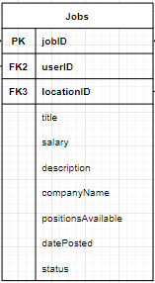

Sample Data

|  |  |  |  |  |  |  |  |  |  |
| --- | --- | --- | --- | --- | --- | --- | --- | --- | --- |
| **jobID** | **userID (FK)** | **locationID (FK)** | **title** | **salary** | **description** | **companyName** | **positions**  **Available** | **datePosted** | **status** |
| **1** | **2** | **1** | **Software Dev** | **84000** | **Angular** | **Amazon** | **5** | **12/20/19** | **Filled** |
| **2** | **1** | **2** | **Front End Dev** | **35000** | **React** | **Facebook** | **1** | **11/3/2020** | **Open** |

**1NF**: This table is in 1NF because all the columns hold atomic values.

**2NF**: This table is in 2NF because it is in 1NF and there are no partial dependencies.

**3NF:** This table is in 3NF because it is in 2NF and there are no transitive dependencies

as all columns depend only on the jobID key.

1. **Job_Categories_List Table**

Schema

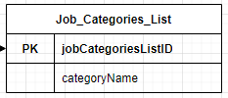

Sample Data

|  |  |
| --- | --- |
| **jobCategoriesListID** | **categoryName** |
| **1** | **Javascript** |
| **2** | **React** |
| **3** | **Angular** |
| **4** | **PHP** |

**1NF**: This table is in 1NF because all the columns hold atomic values.

**2NF**: This table is in 2NF because it is in 1NF and there are no partial dependencies.

**3NF:** This table is in 3NF because it is in 2NF and there are no transitive dependencies

as all columns depend only on the unique jobCategoriesListID key.

1. **Job_Categories Table**

Schema

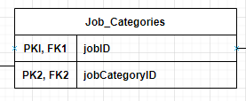

Sample Data

|  |  |
| --- | --- |
| **jobID** | **jobCategoryID** |
| **1** | **2** |
| **2** | **1** |
| **3** | **3** |
| **4** | **1** |

**1NF**: This table is in 1NF because all the columns hold atomic values.

**2NF**: This table is in 2NF because it is in 1NF and there are no partial dependencies.

**3NF:** This table is in 3NF because it is in 2NF and there are no transitive dependencies

since columns are FKs and PKs in order to connect the job and its categories.

1. **Applications Table**

Schema

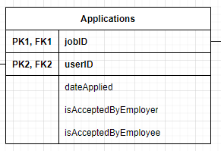

Sample Data

|  |  |  |  |  |
| --- | --- | --- | --- | --- |
| **jobID** | **userID** | **dateApplied** | **isAcceptedByEmployer** | **isAcceptedByEEmployee** |
| **1** | **1** | **3/5/2020** | **False** | **False** |
| **2** | **2** | **2/7/2020** | **True** | **True** |
| **3** | **1** | **4/5/2020** | **True** | **False** |
| **1** | **3** | **4/9/2020** | **True** | **True** |

**1NF**: This table is in 1NF because all the columns hold atomic values.

**2NF**: This table is in 2NF because it is in 1NF and there are no partial dependencies.

**3NF:** This table is in 3NF because it is in 2NF and there are no transitive dependencies

as all non-prime columns depend on both the userID and jobID both are required

to uniquely identify the application.

1. **Emails Table**

Schema

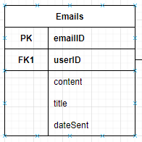

Sample Data

|  |  |  |  |  |
| --- | --- | --- | --- | --- |
| **emailID** | **userID (FK)** | **content** | **title** | **dateSent** |
| **1** | **2** | **Hello World** | **Forgot Password** | **3/5/2020** |
| **2** | **4** | **Hello World** | **Forgot Password** | **2/7/2020** |
| **3** | **1** | **Hello World** | **Forgot Password** | **4/5/2020** |
| **4** | **6** | **Hello World** | **Forgot Password** | **4/9/2020** |

**1NF**: This table is in 1NF because all the columns hold atomic values.

**2NF**: This table is in 2NF because it is in 1NF and there are no partial dependencies.

**3NF:** This table is in 3NF because it is in 2NF and there are no transitive dependencies

as all columns depend only on the unique, auto incrementing, emailID key.

1. **Employer_Categories Table**

Schema

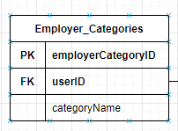

Sample Data

|  |  |  |
| --- | --- | --- |
| **employerCategoryID** | **userID (FK)** | **categoryName** |
| **1** | **1** | **Senior HR Manager** |
| **2** | **1** | **Tech Lead** |
| **3** | **1** | **Junior HR** |
| **1** | **3** | **Project Manager** |

**1NF**: This table is in 1NF because all the columns hold atomic values.

**2NF**: This table is in 2NF because it is in 1NF and there are no partial dependencies.

**3NF:** This table is in 3NF because it is in 2NF and there are no transitive dependencies

as all non-prime columns depend on only the employerCategoryID key.

1. **Payment_MethodsTable**

Schema

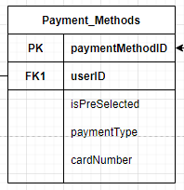

Sample Data

|  |  |  |  |  |
| --- | --- | --- | --- | --- |
| **paymentMethodID** | **userID (FK)** | **isPreSelected** | **paymentType** | **cardNumber** |
| **1** | **1** | **True** | **Credit Card** | **2846\*\*\*\*\*\*\*\*** |
| **2** | **1** | **False** | **Checking Account** | **1561\*\*\*\*\*\*\*\*** |
| **3** | **2** | **False** | **Credit Card** | **5511\*\*\*\*\*\*\*\*** |
| **1** | **3** | **True** | **Credit Card** | **3334\*\*\*\*\*\*\*\*** |

**1NF**: This table is in 1NF because all the columns hold atomic values.

**2NF**: This table is in 2NF because it is in 1NF and there are no partial dependencies.

**3NF:** This table is in 3NF because it is in 2NF and there are no transitive dependencies

as all non-prime columns depend only on the auto-incrementing paymentMethodID key

1. **PaymentsTable**

Schema

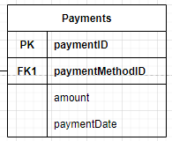

Sample Data

|  |  |  |  |
| --- | --- | --- | --- |
| **paymentID** | **PaymentMethodID(FK)** | **amount** | **paymentDate** |
| **1** | **1** | **10.00** | **12/12/20** |
| **2** | **1** | **100.00** | **11/08/19** |
| **3** | **2** | **50.00** | **11/06/19** |
| **1** | **3** | **20.00** | **11/08/18** |

**1NF**: This table is in 1NF because all the columns hold atomic values.

**2NF**: This table is in 2NF because it is in 1NF and there are no partial dependencies.

**3NF:** This table is in 3NF because it is in 2NF and there are no transitive dependencies

as all non-prime columns depend only on the auto-incrementing paymentID key